**[Formula SAE Fuel Tank](https://seelio.com/w/7gd/formula-sae-fuel-tank)**

This project is the fuel tank of the 2013-2014 Formula SAE subsystem. I was the subsystem captain for all of the fuel system. As subsystem captain, I had to design, manufacture, test, and implement the fuel tank of our Formula SAE race car RW7. The goal this year was to reduce the weight without compromising the integrity of the system or reducing the fuel tank capacity. I have been a member of Wayne State University's Formula SAE team (Warrior Racing) since I began attending Wayne State in August 2010. I joined Formula SAE because I have a passion for the automotive field and automotive racing. I was the head of this project and am working on the design, testing, and manufacturing process. I learned Solidworks desgin processes for fuel tank as well as improving upon previous designs, Finite Element Analysis (FEA) of the fuel regulator and other components, and the manufacturing process of components including plasma cutting, milling, lathe work, and welding.

* 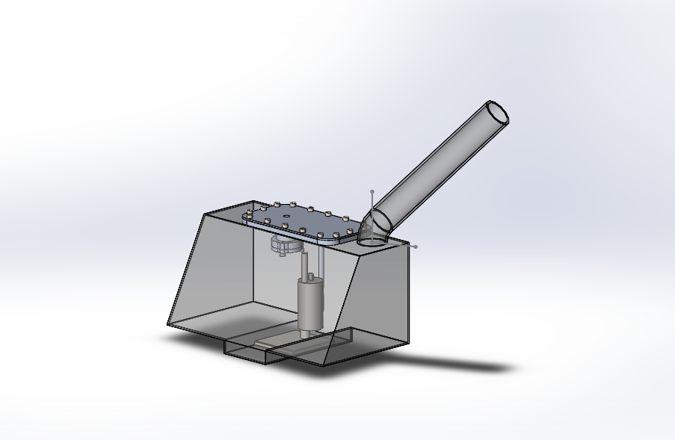

Fuel tank overview

×

* 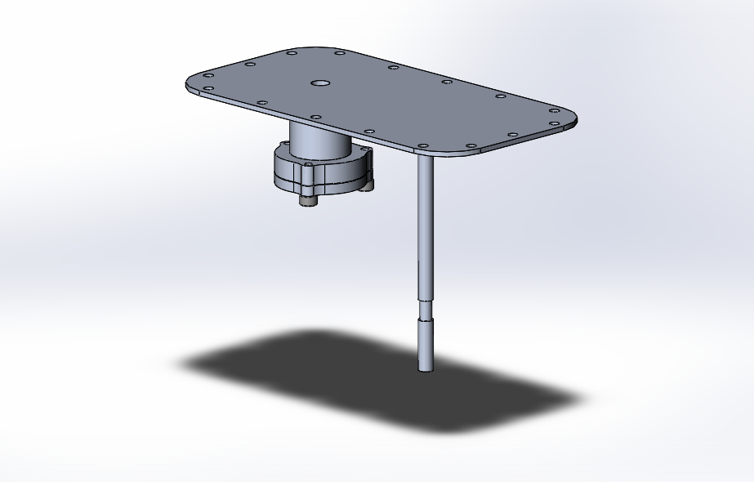

Fuel tank lid incorporating the fuel regulator assembly